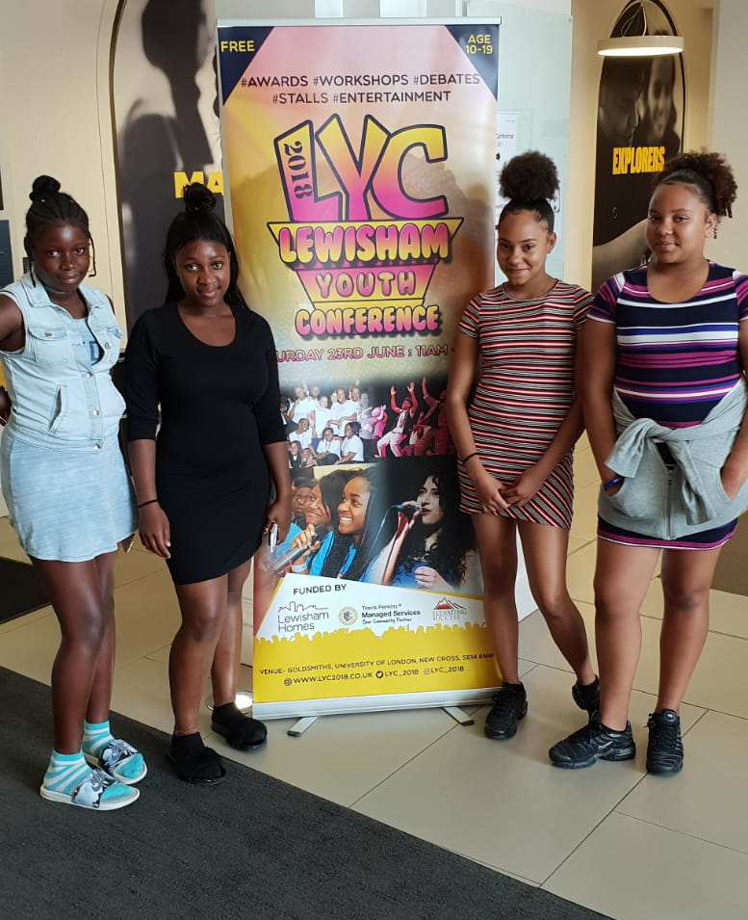
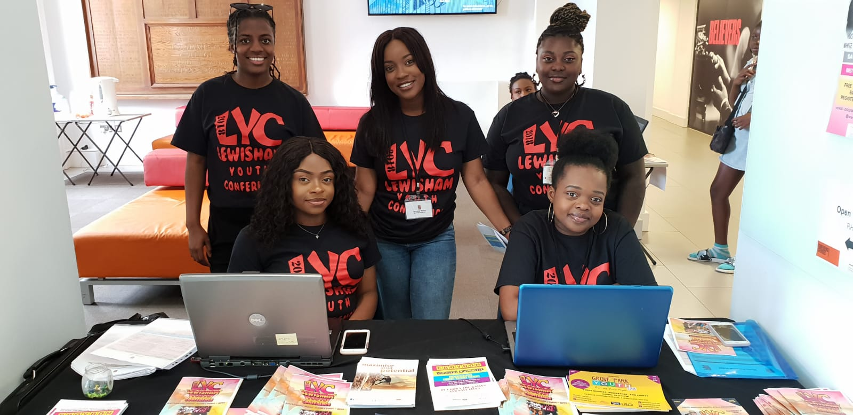

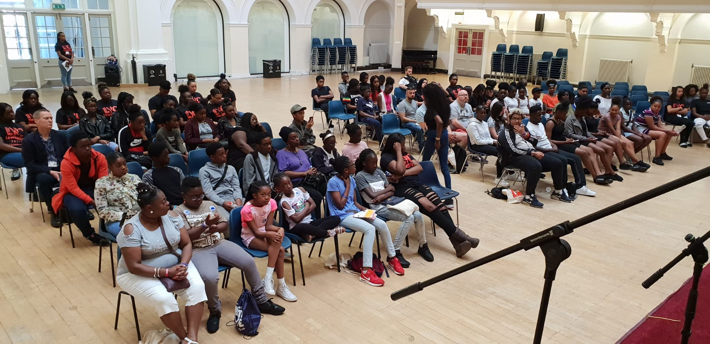

ANNUAL REPORT
17/18

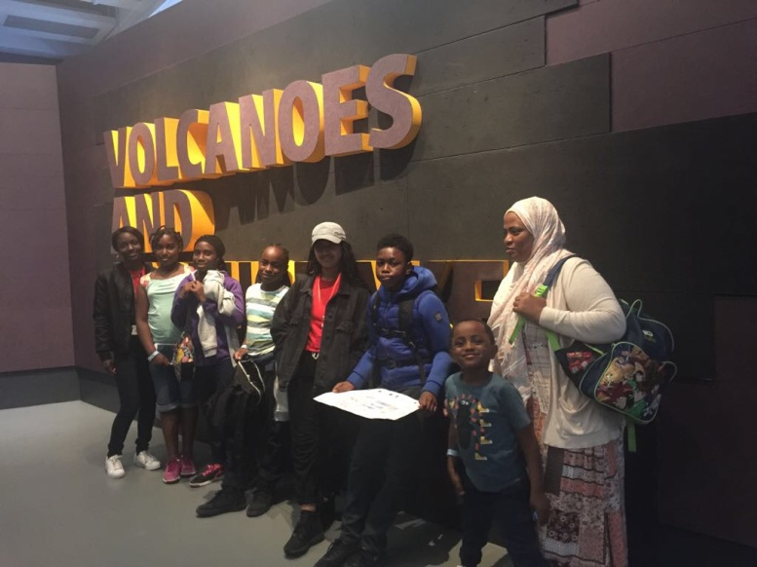

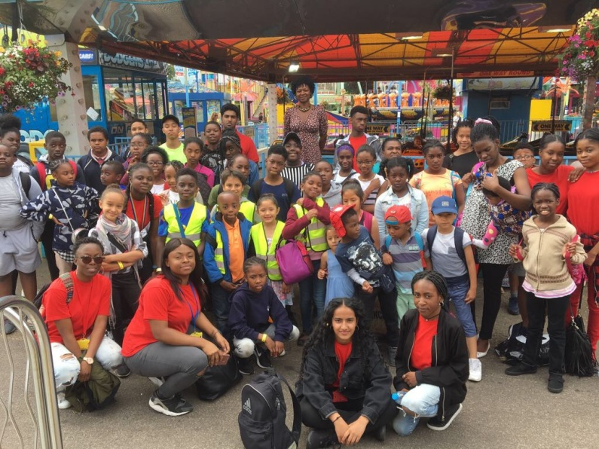
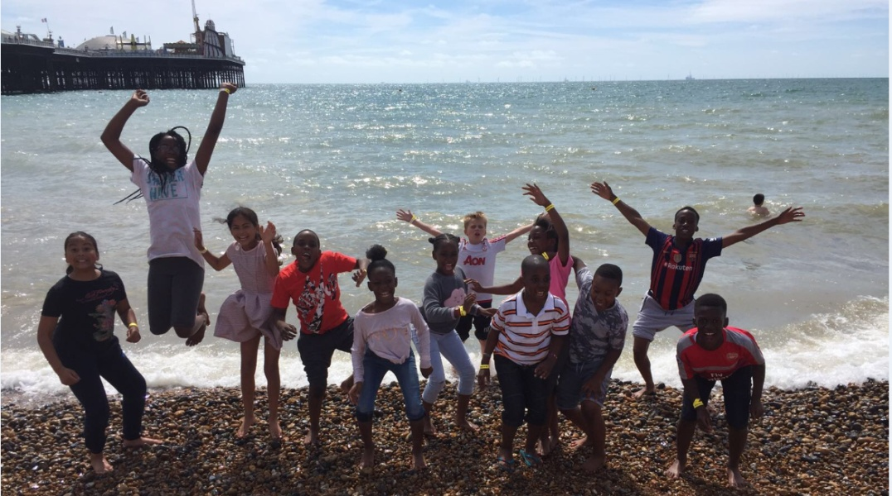

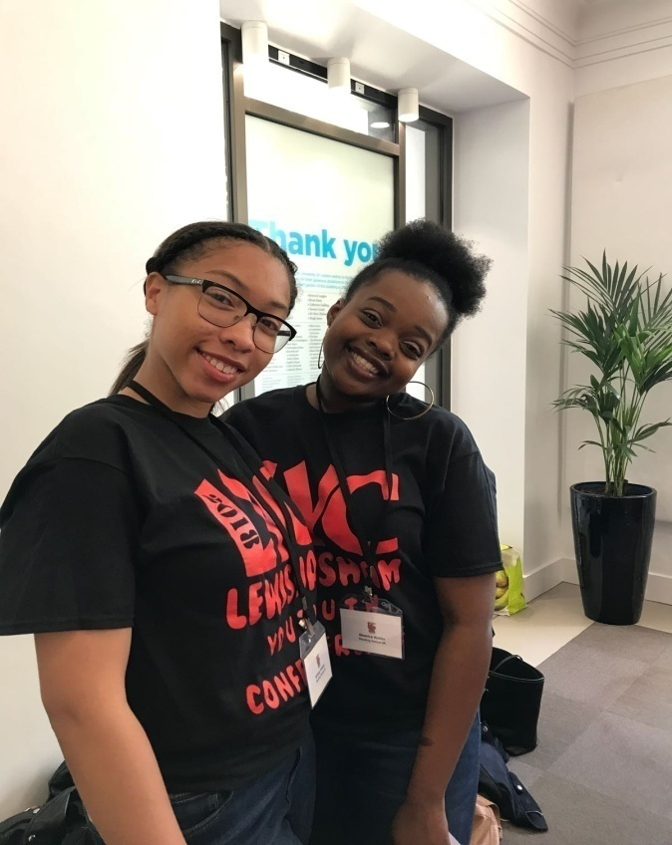

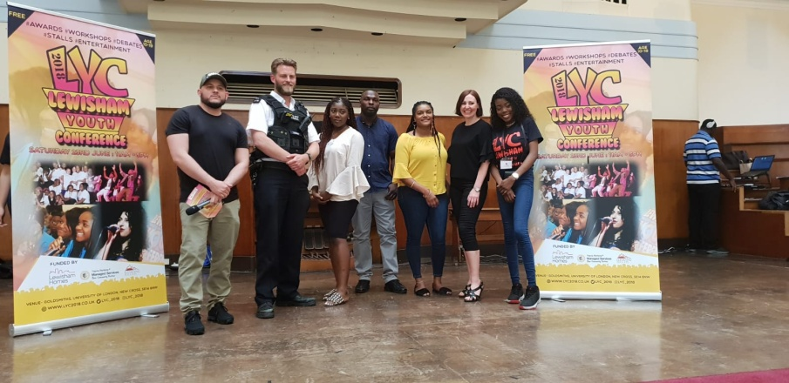

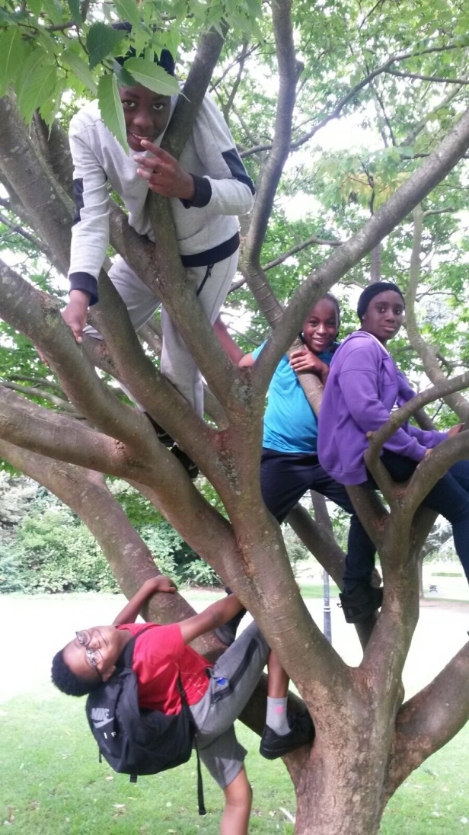

CONTENTS PAGE

About Us.................................................................................................................................................3
Aims & Objectives...................................................................................................................................4
CEO & Chairperson Reports....................................................................................................................5
New Partnerships....................................................................................................................................6
Developing Talent………………………………………………………………………………………………………………………………7
Achievements & Performances
NLMHA Summer Holiday Programme.......................................................................................8
CCHA Schools-Out Summer Programme...................................................................................9
Clapham Park Schools-Out Summer Programme....................................................................10
L&Q Lewington Centre Holiday Foundation............................................................................11
Ready, Steady, Work Programme............................................................................................12
Grove Park Youth Club………………………………………………………………………………………………………..13
Metropolitan Study Hub……………………………………………………………………………………………………14
10 Years of Memories...........................................................................................................................15
Programme Beneficiaries......................................................................................................................16
Case Studies..........................................................................................................................................17
Thanks & Acknowledgements...............................................................................................................18
Contact Us.............................................................................................................................................19

ABOUT US
Elevating Success UK is a training and personal development charity based in South London with a reach that extends across the capital. Established in November 2007, the organisation has charitable status and works with approximately 1400 individuals per year, consisting of children, young people and adults. Our aim is to support individuals to achieve their full potential. Today we have six delivery areas: Employability Skills, Rehabilitating Officers, Personal Development, Holiday Programmes, Community Development and Event Management.
Our training is free at the point of access with funding sources from a variety of organisations including local and central government, larger charities and a number of social housing providers who see the benefit of empowering their tenants to become economically independent.
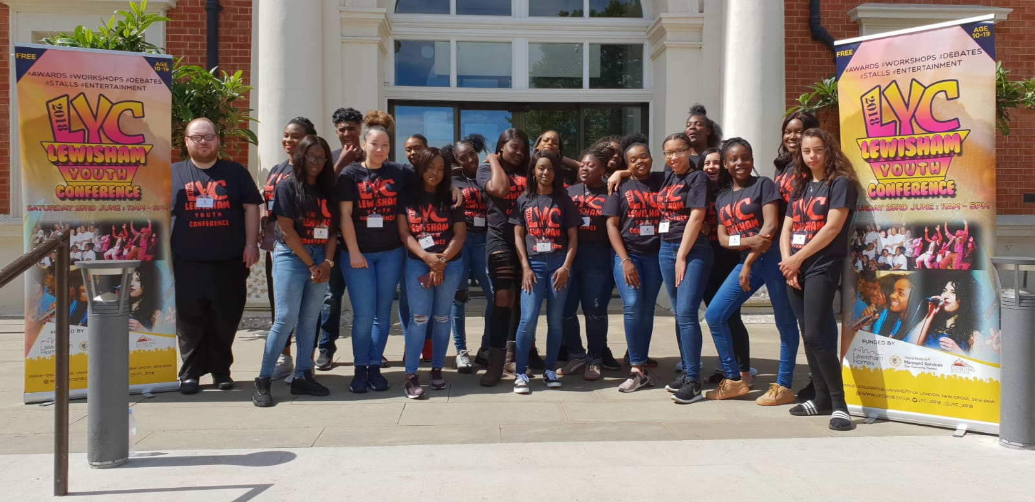
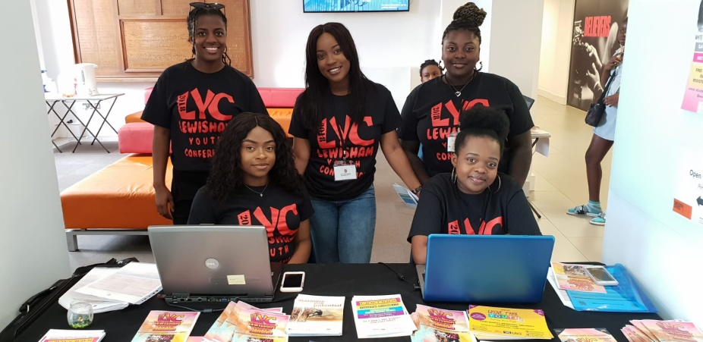
Our holiday programmes run every half-term over the last five years. These programmes were created in response to consultations with schools that revealed some children were not exposed to opportunities that could enhance their life outcomes; May it be chances to socialise in a safe environment or experience new activities that challenge them. Over these last five years we’ve provided activities for over 500 young people.
Our work with offending communities has seen us work with Lewisham Youth Offending Services for five years and the London Probation Trust (now CRC) for four years. Our aim is to engage, educate and support individuals to make life choices that will see them end a cycle of offending. These programmes focus on changing behaviour, as well as providing qualifications that enhance employment prospects.
In the last five years, we have launched two youth conferences, managed six events and attracted over 3,000 young people, providing guidance and support on career opportunities as voluntary community roles.

We are aware of the benefit our work brings and the fact that we’ve been in existence for ten years is testimony to our success of convincing others of the relevance of our work.
We are seeking to develop relationships with corporate organisations where their input – both financial and in the form of work placements/internships and job opportunities – will enable them to showcase their CSR credentials and most importantly make a meaningful impact on the lives of people who are disadvantaged.

To discuss how you can contribute to our vision please contact: 020 7993 8411

AIMS AND OBJECTIVES
AIMS
- Elevating Success UK aims to provide a professional, caring and mutually respectful training service to all clientele, ensuring that the needs and wants of each individual are met to the best of our ability.
- We pride ourselves on being able to offer flexible, professional and dependable services at all times regardless of age, ethnicity or gender.
- We continually seek to promote and disseminate good practice.
- We aim to provide assistance and partnership support to regenerate priority areas and develop sustainable communities.

OBJECTIVES
- To deliver training and educational programmes that are recognised as high-quality, achieve the best value for money in all activities and develop links with businesses so that disadvantaged people have the opportunity to try activities and projects appropriately.
- Our programmes are free at the point of access in recognition of the fact that our end users are drawn from areas of high deprivation, be they children, teenagers, young adults or senior citizens. We will champion partnership working and have nurtured a number of valuable business relationships, mainly due to our fantastic team of employees and volunteers who share our vision and are committed to delivering services to a very high standard.

CEO AND CHAIRPERSON REPORTS
Andrew Brown
CEO of Elevating Success UK
Our tenth year of trading has proved increasingly more difficult than the previous. With further funding cuts we have struggled financially and have been forced to dip into our reserves to meet the additional expenditure. However, we have also been able to effectively deliver numerous projects and programs, keeping the high standard we set ourselves.
We had another successful year working with over 1,150 individuals. We were also able to keep working with existing funders CCHA, Lewisham Homes & Travis Perkins whilst attracting new funders in Metropolitan Housing and the North London Muslim Housing Association.
We have continued to deliver our vast array of successful programmes whilst adding two new ‘Schools-Out Summer Holiday Programmes’ funded by the aforementioned Metropolitan Housing and NLMHA.
This comment, made after our CCHA Summer Programme, made epitomises what the charity is about and how it contributes to the community:
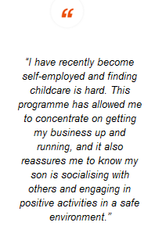

Vanessa Clarke
Chairperson, Board of Trustees
We are very pleased to present another annual report celebrating a successful year ending March 31st 2018.
As per usual, the majority of our funding has come from housing associations and grant funding, such as the Evening Standard Dispossessed Fund and London Community Foundation, with Metropolitan Housing Trust and North London Muslim Housing Association major contributors throughout the year.
It is always rewarding to hear the success stories provided by both our younger and older participants who have completed our programmes and progressed in to employment, further education or setting up their own businesses.
None of these success stories would be achieved without the vision and leadership skills of our CEO, Andrew Brown, together with the continued dedication and expertise of our incredible team of staff, Ben Joyce and Patricia Stevenson, our volunteers and supporters whose generous donations of time and money are always welcomed and appreciated greatly. We are looking forward to further impacting the lives of many in a positive fashion, and always strive to improve as an organisation.
Below is a quote from the Neighbourhood Investment Lead at Metropolitan Housing Trust:

OUR NEW PARTNERS
Metropolitan Housing Trust is one of the UK’s leading providers of affordable housing, care and support services.
Elevating Success UK began working with Metropolitan Housing Association in July 2017, when they provided funding for us to run the Metropolitan Housing School’s Out Summer Programme 2017.
The programme lasted six weeks and ran from July and August, providing young people aged 7-15 with the opportunity to take part in both onsite activities and offsite trips.
At the same time, we delivered an On The Road: Driving Theory Programme for people aged 17+. This project was a huge success, working with 23 people, 14 of whom graduated.
During the programme, we also worked with three young volunteers, all Metropolitan tenants who assisted with the School’s Out Summer Programme. It was fantastic to be able to give three young people valuable experience in the working world.
Moving forward, we see a fruitful partnership with Metropolitan developing and look forward to working with them again.

North London Muslim Housing Association (NLMHA) is a not-for-profit organisation which seeks to provide outstanding customer service.
Elevating Success UK began working with NLMHA in July 2017, when they backed Elevating Success UK to deliver holiday activities under the banner of our School’s Out Summer Programme.
This four-week programme epitomised what it means to engage a whole community. While activities were primarily targeted at 8-16 year olds a number of trips lent themselves to wider participation and saw mothers, grandmothers and fathers pitching in for family fun.

Developing Talent
Tyriesha Davis – Volunteer
Tyriesha is a Metropolitan Housing Trust tenant and was a learner on the first On The Road: Driving Theory Programme run in partnership with Metropolitan.
It quickly became apparent to us that Tyriesha has an aptitude for youth work, and she was offered a voluntary role on our School’s Out Summer Programme.
During her six-week voluntary period, it was clear that Tyriesha was a hard working individual who connected well with the young people. Her efforts were noticed by staff and she was asked if she’d be interested in working at the soon to launch Study Hub.
Tyriesha accepted and became a paid member of staff and a valuable member of our team. In the six months that followed, she worked on a number of projects including the Study Hub, an On The Road programme and our Grove Park Holiday Programme.
We have been very pleased with the progression Tyriesha Davis has made and look forward to working with her over the coming years.

Sabrina Watson – DMU Intern
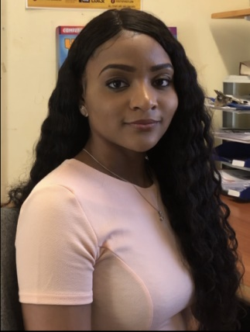
Sabrina completed a six-week placement with Elevating Success UK as part of the DMU Champions Scheme, which places graduates into paid positions to gain valuable experience.
Her main task was to manage our social media accounts. That included monitoring accounts, posting content, promoting upcoming events and creating schedules for social media posts.
In her own words:
“I’ve been able to use skills I learnt from my journalism degree, such as writing in different styles. And I’ve been consistently encouraged to do things that were out of my comfort zone but that would help me long term. For example preparing and delivering a presentation at a workshop, and applying for a job by making a video application.
So in all, my time at Elevating Success has helped me gain more confidence in my writing abilities and I’ve been given advice on the next step - career-wise - too.
I would encourage everyone who needs guidance, either as a student or a graduate, to gain experience at Elevating Success. It’s a chance to work with wonderful people who care.”
We have been delighted with Sabrina’s placement and wish her all the best in the future.
NLMHA SUMMER PROGRAMME 2017
The NLMHA Summer Holiday Programme 2017 was a four-week programme full of activities to draw tenants together. The Finsbury Grange site and Oriana House in Leyton acted as a hub for a total of 40 children aged 8-16 who were provided with offsite activities four days a week.
The visit to Capel Manor Gardens was a standout moment of the programme. Each child took upon leadership duties leading the group through the gardens requiring them to use their orienteering skills. It aided the more timid children in finding their confidence. The day helped build team spirit and culminated in eating fresh handpicked fruit from the orchard.
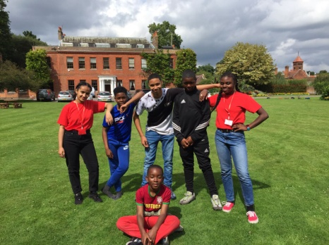
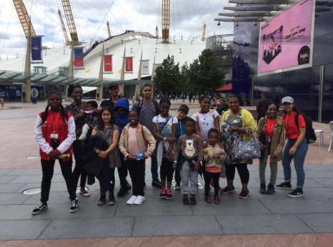
The visit to the Emirates Centre to learn about the technology used to fly planes and the visit to the Nissan Innovation Centre also stood out within the programme. The latter enabled the children to interact with a number of exhibits including interactive quizzes, wear virtual reality goggles and pit their stamina and response rates against athletes in an onsite physical agility test. The children enjoyed the days out with a particular young person describing it as “The best summer of my life”.

4
Weeks of Activities
28 Young People

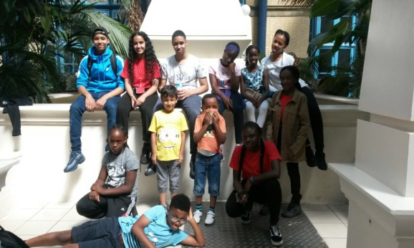

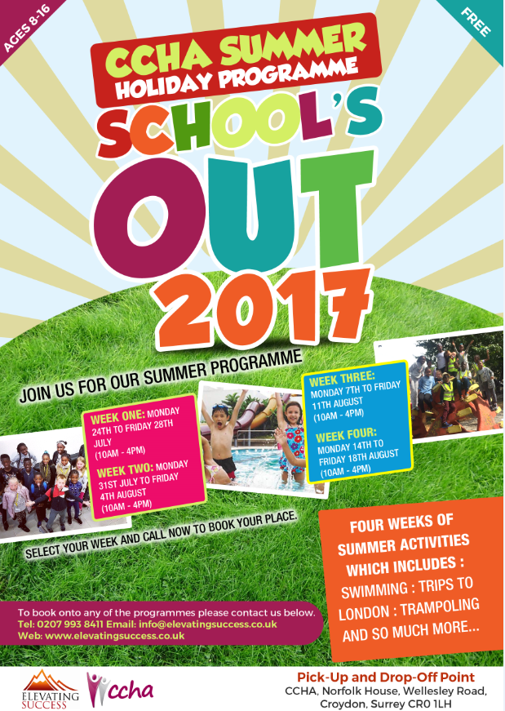
CCHA SCHOOL’S OUT SUMER PROGRAMME 2017
For the sixth year in a row CCHA funded the School’s Out Summer Holiday Programme which ran for a total of four week, the longest to date. 31 unique individuals from Croydon and surrounding areas, aged 7-15 attended four weeks of activities. A dedicated team of three youth workers, supported by four volunteers (three of whom were CCHA residents and former attendees of the programme) oversaw each day’s activities and provided a safe environment for the participants.
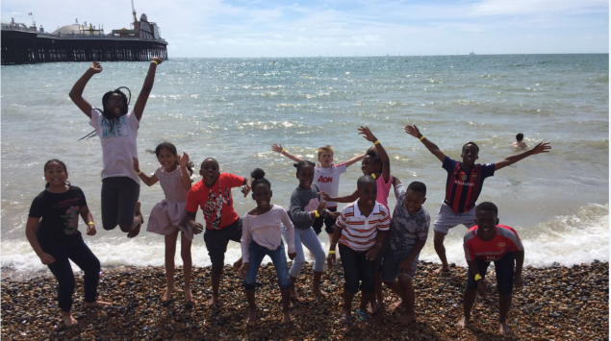
Participants took part in a wide variety of activities from Laser Quest, Cinema trips and Bowling to the Natural History Museum and the Science Museum.

At the end of the programme the participants were asked to provide feedback to capture relevant information to improve future programmes. The trip to Frylands Wood was identified as a highlight among the young people with a participant stating “Frylands Wood was very fun. I got to shoot a bow and arrow and take part in other activities.”
Activities were designed to be both fun and educational; as a result we asked young people what they learnt during the programme with personal development often mentioned by respondents. Parents also provided feedback on the event with one particular parent stating: “My child was new to the area and didn’t know anybody. He made plenty of new friends on the programme and is now very happy living here.”
Feedback received was so positive with few suggestions for improvement, and focused on how the programme has positively affected young people. For future programmes we will explore further locations to keep it fresh for all attendees.
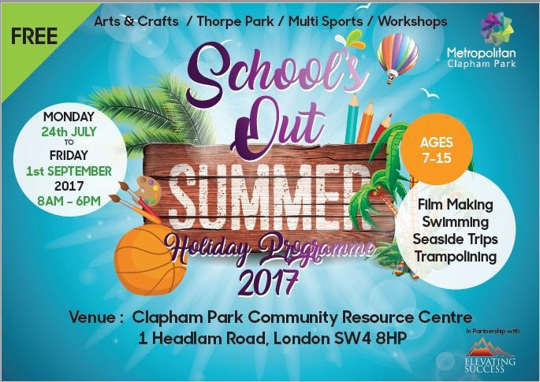
METROPOLITAN HOUSING TRUST
CLAPHAM PARK SCHOOL’S OUT SUMMER PROGRAMME 2017
Summer 2017 represented the first time we have been given the opportunity to work with Metropolitan Housing Trust to deliver the Clapham Park Schools-Out Summer Holiday Programme. We ran activities both on and off site, allowing young people to enjoy a range of experiences and adventures. 134 young people aged 7-15 signed up (74 on the programme & 60 on the waiting list) and attended at least two weeks of activities.
The trips provided young people with the opportunity to bond with members of staff, reduce feelings of isolation and provide them with the opportunity to make new friends. They took part in various activities ranging from Film Making, Arts and Dance to field trips and excursions to Eagle Heights, Addington Park and Bowling.
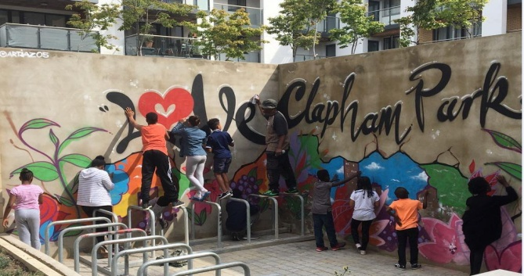

The programme was facilitated by nine youth workers, most of whom had several years’ experience, we also had five young volunteers.
The Thorpe Park trip was identified as a programme highlight, earning a whopping 230 attendees with one young person saying “I have never been to a theme park before”. Our activities aim to be both fun and educational with young people identifying they “learned how to work as a team and push to the end” in addition to learning how to use a filming camera.
34 MALE
40 FEMALE
74 ATTENDEES

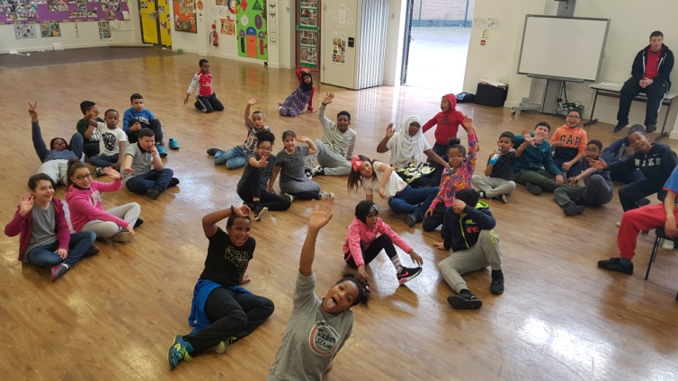
L&Q FOUNDATION
THE LEWINGTON CENTRE HOLDIAY PROGRAMME
It consists of fun and educational activities and workshops, including, cooking, creative arts, dance, drama, music, photography, sports and many more.
The four week programme provides young people with new and challenging workshops, as well as fun activities to stimulate, motivate, and inspire young people to become active and contributing members to their community.
The key aim of the programme was to provide a safe environment for young people to spend their school holidays, taking part in constructive activities that may otherwise be unavailable to them.
The project offers young people with a place to interact with friends, socialise with people they wouldn’t normally and take part in engaging activities with tangible outcomes.
We aim to nurture talent, building a relationship of trust in hope that at 16, attendees can progress to the role of volunteer and be given leadership responsibilities in running the project alongside seasonal staff.
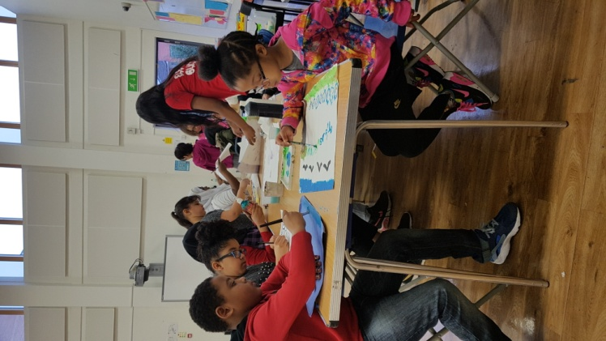
75% IMPROVED SOCIALLY
75% IMPROVED CONFIDENCE
57 ATTENDEES

The programme consisted of 20 days of fun and educational activities and workshops for young people aged 8-16, focusing on confidence building, staying healthy and creativity.
Running from the Lewington Centre in Rotherhithe, the project ended up working with 57 individuals from the local area.
We arranged a number of activities and workshops including sports, arts & crafts, empowerment workshops and cooking. Whilst also arranging for the young people to visit many fantastic locations including the cinema, laser quest, bowling and swimming. We extended the programme for one extra day taking 20 people to Thorpe Park.

“The summer programme allows me to look after my younger children while my older child can take part in fun activities he’s never done before”.

READY, STEADY, WORK PROGRAMME
The Ready, Steady, Work programme is a six-week course designed to help you take control of your own life. Over the course of the programme attendees took part in workshops to improve their employability skills, CV writing, financial management and healthy eating.
The Ready, Steady, Work programme (rebranded as Health & Wealth) was delivered to a total of 26 learners of which only 1 was male. 23 of the learners secured a level 2 food safety and hygiene award with one learner not able to complete the course due to poor health whilst the other two withdrew from the programme due to family circumstances.
Participants lived, or came from communities that are defined as disadvantaged in some way. Each group, though very different in composition, saw a significant number of candidates derive benefits, be it those who secured employment (20%), those who improved their life chances by engaging in further training, earning a work placement or establishing a CIC or those who enhanced both their knowledge and confidence.
The programme consisted of three separate programmes each designed to focus on different employability skills to help attendee’s chances of employment. The first course focused on helping participants achieve a Level 2 Food Safety & Hygiene Award; the course had seven attendees. As a result of the course two candidates were able to secure employment, whilst another went on to study Catering & Hospitality at Lambeth College.
1
To Study Catering
20% Employment Rate

3
Businesses Set-Up

The second programme was delivered in Lambeth, extending the opportunity to more people. Drawing on our relationship with Metropolitan Housing the course was focused towards residents living in the Clapham area. It focused on qualification and job search techniques, as well as progression support. One attendee was inspired to set up a CIC, receiving business advice from us. Another attendee was offered placement to work for us however, shortly after, found an alternative role.
Finally, the third course was the Vietnamese Supplementary School which saw thirteen attendees aged 40-65 achieve their Level 2 Food Safety & Hygiene Award whilst also gaining additional knowledge and guidance. A number of attendees benefited from the flexibility of the course with the majority of women working 6 days a week. Cooking and eating together was also a part of the community’s interaction which included activities such as English language lessons and IT classes.

Grove Park Youth Club
The Grove Park Youth Club was a new project launched in partnership with Youth First in September 2017.
The club ran three nights per week during term time and gave young people aged 8-16 a safe, secure environment at which they could have fun after school.
During the first year, we delivered 117 sessions, attracted 99 individuals. Young people took part in many activities, including arts & crafts, sports and cooking.
As well as the onsite activities, young people were also treated to an offsite trip every term, going to locations such as the cinema and bowling.
Taking place over such a long period of time, staff members were able to build a rapport with attendees, meaning they could help them develop on a personal level by identifying issues they were facing and come up with suitable solutions to these issues.

117
Sessions
99 Attendees

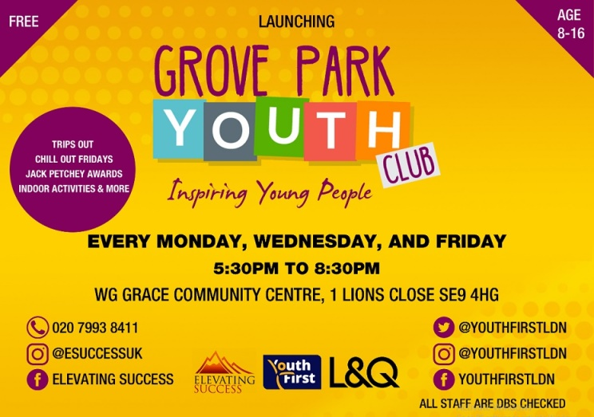
The Youth Club will continue into the new financial year, running until August 2019. We aim to introduce new aspects to the project, including workshops designed to educate young people while also allowing them to have fun.
Furthermore, we will be aiming to achieve a Bronze Quality Mark from London Youth, making us a recognised centre of excellence when it comes to working with young people.

Metropolitan Study Hub
The Metropolitan Study Hub was a brand new project launched in September 2017 in conjunction with Metropolitan Housing Trust.
The Study Hub sessions happened every Saturday from 11am-2pm, with the first hour dedicated to 7-11 year olds, and the final two hours for 12-16 year olds.
Running for 27 sessions over the first six months, we attracted 35 unique individuals to the session, most of whom were repeat attendees.
Staff were on hand to assist young people with their work and provide addition worksheets/activities for those who had finished early or didn’t have any homework.

27
Sessions
35 Attendees

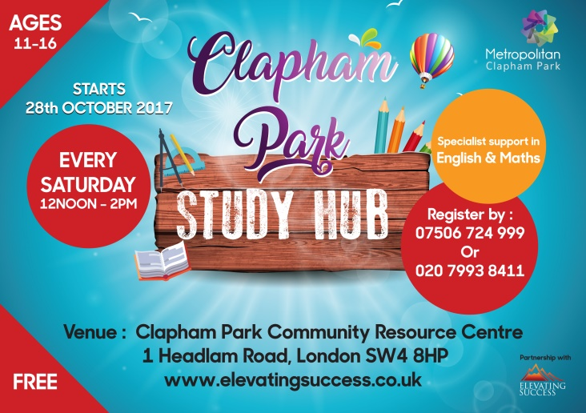
Set to run for a further 18 months, the Study Hub will go from strength to strength, attracting new young people from the Clapham Park community.
The aim is to secure further funding to continue to grow this project, perhaps expanding into other areas, or attracting attendees from outside of the Clapham Park community.

Metropolitan Study Hub
Started September 2017
35 attendees
Homework Club
Two Groups – 7-11 from 11am-12pm
11 (high school) to 16 12-2pm
Every Saturday
10 YEARS OF MEMORIES

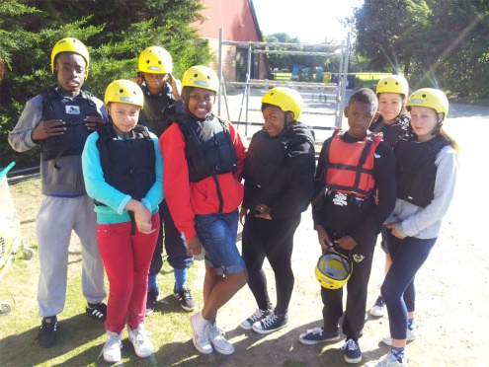
AmicusHorizon Residential 2014
Jewellery Making 2012
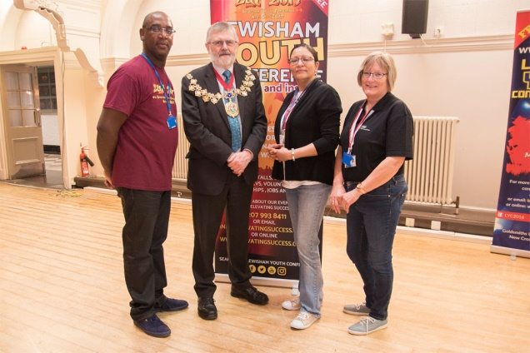
LYC 2017
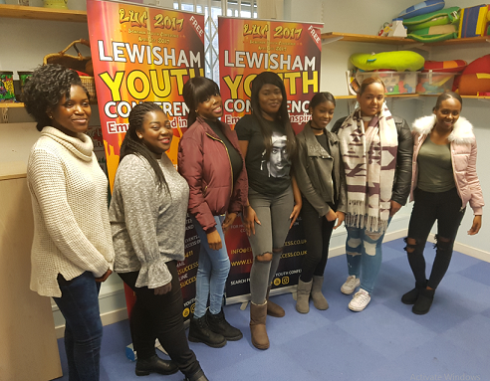LYC 2017

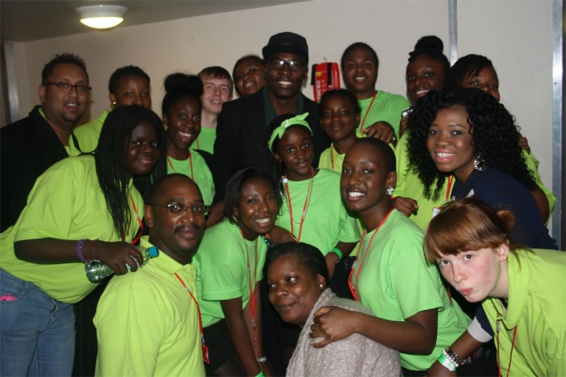Momentum Youth Conference 2012
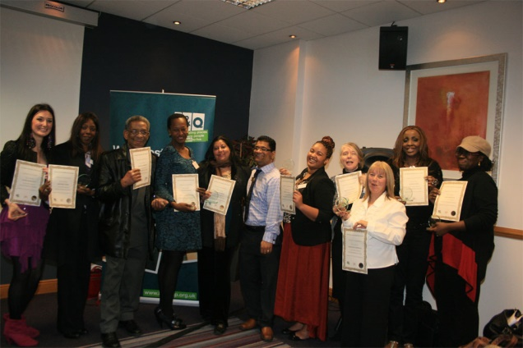
L&Q Business Enterprise Programme 2011
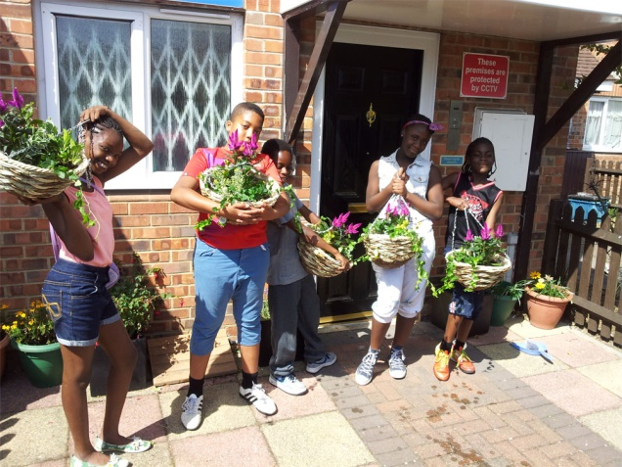
AmicusHorizon Environmental Project 2013
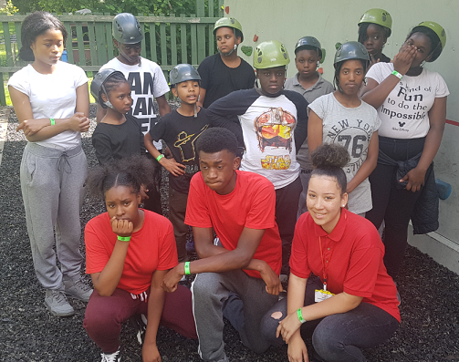

PROGRAMME BENEFICIARIES
During the 2017/18 financial year, Elevating Success UK ran 31 projects or programmes, working with 1,136 people.
Continuing our work in Bromley, Croydon, Lewisham and Rotherhithe we also branched out into North London for the first time.
From Employability Skills, to Driving Theory, Homework Clubs to gender-specific mentoring, Youth Conferences to Holiday Programmes, we delivered a variety of programmes to people ranging in age from seven-65.
We have continued to go from strength to strength this year, emphasised by the amount of individuals who accessed more than one of our programmes during the year.
No fewer than 311 individuals participated in more than one programme.

Programmes targeted at Young People aged 7-19

• Youth Club
• Study Hub
• Holiday Programmes
• Youth Forums

Programmes offering Employment access support

• On The Road: Driving Theory
• Pathway to Work in Catering & Hospitality
• Pathway to Work in Construction

Chanel Bailey
Case Study
Chanel, age 14, originally joined the School’s Out Programme during week three as a participant and it was immediately evident that she had real leadership potential, especially when it came to engaging with her peers.
The director of Elevating Success UK asked if she would be interested in volunteering as a youth worker on the programme and she was keen to become involved. She then met with the project leader who sat with her and explained what the programme entailed, what was expected from a youth leader and how the experience would benefit her, as a young person from the local area, in the future.
After a week’s trial, she was delighted to be given her red t-shirt, signifying that she was now officially one of the recognised youth leaders on the programme. Chanel proved to be a tremendous addition to the team, able to lead small groups on offsite trips, assisting in the choreography of the dance that was performed at the Love Clapham Park Fun Day on the 19th August and being a firm favourite with the younger children on the programme because of her ability to relate and the energy she brought to the programme.
From the day that Chanel attended the programme to the day it concluded, she has been an inspirational youth leader for her peers and we are looking forward to working with her again on other Elevating Success UK initiatives such as our Youth Conferences.

THANKS & ACKNOWLEDGEMENTS
Without our funders and partners, the work we do would not be possible. We would like to offer a huge thanks to all of our partners over the past year and we look forward to working with you all again in the future.
• Awards For All  • Croydon BME Forum  • CCHA  • Clyde Early Childhood Centre  • Easy Fundraising  • Evening Standard Dispossessed Fund  Our Volunteers and Interns  Thank you to all of our team over the past 12 months, without whom we would not be able to continue to function at the level we do. Each and every volunteer is an important member of the Elevating Success UK family:  Dominique Bryan  Harry Webster  Nadine Banton  Noah Troudart  Sabrina Watson  Segun Morris  Wahida Ali Said | • In Kind Direct  • Lewisham Homes  • Local Giving  • London and Quadrant  • London Community Foundation  • Metropolitan Housing Trust  • Metropolitan Police  Our Valued Trustees  Vanessa Clarke  Chairperson  Devon Hobbs  Treasurer  Andrea Beveney  Secretary  Anne-Marie Nicholls  Trustee  John Opara  Board Member  Our Valued Trustees  Vanessa Clarke  Chairperson  Devon Hobbs  Treasurer  Andrea Beveney  Secretary  John Opara  Trustee  Anne-Marie Nicholls  Trustee  Angela Nelson  Board Member | • NCS: The Challenge  • North London Muslim  Housing Association  • Optivo  • Seetec  • Travis Perkins  • Youth First

CONTACT US
Head Office
Honor Oak Old Depot
St. Norbert Road
Brockley
London
SE4 2EY

General Enquiries
Telephone:
020 7993 8411
Website: www.elevatingsuccess.co.uk
E-Mail: info@elevatingsuccess.co.uk

ESuccessUK
@ESuccessUK
/elevatingsuccessuk
Like our Facebook Page
Follow us on Twitter
Follow us on Instagram

